

**Nimshi Dishali Palihawadana**

1722856

**Customized Web Based Software** **For**

**Customer Handling At L.N.D. Graphics**

**(PVT) Ltd.**

BSc (Hons) Computer Science and Software Engineering

Undergraduate Thesis Report

Department of Computer Science & Technology University of Bedfordshire

Ms. Dilushinie Fernando

**AY 17/18**

Abstract

Automated Quotation systems and CRM systems are principally utilized in organizations nowadays to do their work effectively. They do the majority of the things which were physically done in past, for example, quotation producing, sending emails and taking care of customer relationships and transactions. A large portion of them are web-based systems and many are developed in Java and PHP.

The proposed client of the proposed system is an offset printing organization. As of now, the organization doesn't utilize any automated system. They are as yet utilizing the conventional method for emailing and answering to the emails every day by checking the subject and the name. The majority of their pre-production tasks are led by emails and post-production method is done physically. The organization has various objections from clients saying that they don't get their quotations on time and no reaction to their emails.

When utilizing the proposed system clients will have the capacity to ask for quotations online by means of a special web-based GUI and the provider will be informed about the necessity of the client. Whatever remains of the strategy until the point that the payment will likewise be dealt by this proposed system. It will assist the provider with enhancing its customer relationship and it will update the nature of their administration

i

Acknowledgement

Firstly, I want to thank my supervisor Ms. Dilushinie Fernando for her guidance throughout the project. She has advised me on how to do the documentation and suggested several ideas and guided me on developing the proposed system. Secondly, I thank Ms.Gayana Fernando, the lecturer in charge of Undergraduate Project for guiding me from selecting a topic until the final viva. My colleagues at SLIIT were helpful a lot while working on the assignments and other components of the project.

I must also thank my manager, the chairperson of L.N.D. Graphics (PVT) Ltd to allowing me to work on a company’s system and for the immense support I received while working on this project. Also, I be thankful to my fellow co-workers for their support too.

I must thank my family members for being a massive support for me and foe encouraging me to fulfill this project.

A special thanks goes to Mr. Lahiru Senadeera, who guided me and helped me to clarify issues I faced while developing the system.

ii

Dedication

I would like to dedicate my project to my family, lecturer in charge: Ms.Gayana and my

supervisor Ms.Dilushine.

iii

Table of contents

Abstract i

Acknowledgement ii

Dedication iii

Table of contents iv

List of figures vii

List of tables ix

List of Abbreviations x

1. Introduction 1

1.1 Background 1

1.2 Aims and objectives 2

1.3 Project Realization 3

1.4 Structure of the report 4

2.Literature Review 6

2.1 Quotation generation in printing industry 6

2.2 Common quotation generating systems 8

2.3 Data Mining 13

2.4 Customer Relationship Management 15

2.4.1. HUB SPOT CRM 16

2.4.2 PIPEDRIVE: 17

2.5 Similar Systems 18

2.5.1 BITRIX24 19

2.5.2 XERO 20

iv

|  |  |  |  |
| --- | --- | --- | --- |
| 2.5.3 QUOTIENT ............................................................................................................. | | | 22 |
| 3.Methodology ......................................................................................................................... | | | 26 |
| 3.1 | Methodology .................................................................................................................. | | 26 |
| 3.1.1 | | Introduction to methodology ................................................................................... | 26 |
| 3.1.2 | | Prototype methodology............................................................................................ | 26 |
| .......................................................................................................................................... | |  | 27 |
| 3.1.3 | | Benefits of Prototype methodology ......................................................................... | 27 |
| 3.1.4 | | Application of the prototype model ......................................................................... | 27 |
| 3.2 | Planning .......................................................................................................................... | | 27 |
| 3.2.1 | | Current Plan and the progress .................................................................................. | 27 |
| 3.2.2 | | Future Plan ............................................................................................................... | 29 |
| 3.3 | Requirement Gathering & Analysis ............................................................................... | | 29 |
| 3.4 | Design............................................................................................................................. | | 31 |
| 3.4.1 | | System Design ......................................................................................................... | 31 |
| 3.4.2 | | Interface Design ....................................................................................................... | 33 |
| 3.4.3 | | Database Design ...................................................................................................... | 39 |
| 3.5 Implementation............................................................................................................... | | | 39 |
| 3.5.1 | | Technology used ...................................................................................................... | 40 |
| 3.5.2 | | Code segments ......................................................................................................... | 42 |
| 4. Testing and results ............................................................................................................... | | | 48 |
| 4.1 | Testing methods ............................................................................................................. | | 48 |
| 4.2 | Test cases........................................................................................................................ | | 48 |
| 5.Evaluation ............................................................................................................................. | | | 59 |
| 6: Conclusion ........................................................................................................................... | | | 65 |
| 6.1 | Conclusion ...................................................................................................................... | | 65 |

v

6.2 Limitations 66

6.3 Future work 67

References 68

Appendix-A (Gantt chart) 71

Appendix-B (questionnaire) 73

Appendix-C (Poster) 76

vi

List of figures

Figure 1:Print job management system structure(CIMPRESS USA INCORPORATED,

Waltham, MA (US), 2016 8

Figure 2:Common quoting systems-1-outer view (Giovannolli, 1996) 10

Figure 3: Common quoting systems-1-how it works; internal view (Giovannolli, 1996) 10

Figure 4: Flowchart of how the system works (McMahon, Dovalis and Fogarty, 2001) 12

Figure 5:Data mining categories (Kaur, 2017) 13

Figure 6:Pros and Cons in data mining approaches (Rygielski, Wang and Yen, 2002) 15

Figure 7::Hubspot logo 16

Figure 8:Hub spot GUI 17

Figure 9:Pipe drive logo 17

Figure 10:Pipe drive GUI 18

Figure 11:Bitrix24 logo 19

Figure 12:Bitrix24-quote generaing GUI 19

Figure 13: Xero logo 20

Figure 14: Xero-features 21

Figure 15:Quotient logo 22

Figure 16:dashboard GUI-Quotient 23

Figure 17: acceptance One-time: Quotient 23

Figure 18:Overview of prototype model (Google.lk, 2018) 27

Figure 19:WBS 28

Figure 20:Use case diagram 32

vii

Figure 21 High-level architecture diagram 33

Figure 22: Home GUI 34

Figure 23: Login GUI 34

Figure 24:Request quotationGUI-regular customer 35

Figure 25: Request quotationGUI-guest 36

Figure 26:Enter compant detailsGUI 37

Figure 27: Customer Contact details GUI 38

Figure 28: ER diagram 39

Figure 29: PhpStorm 41

Figure 30: Screenshot of PhpMyAdmin 42

Figure 31:Gantt chart-1 71

Figure 32:Gantt chart-2 71

Figure 33:Gantt chart-3 72

Figure 34:Poster 76

viii

List of tables

|  |  |  |
| --- | --- | --- |
| Table 2-0-1 comparison table | | 24 |
| Table 3-0-1 Functional Requirements | | 30 |
| Table 4-0-1Test case-01 | | 48 |
| Table 4-0-2Test case-02 | | 49 |
| Table 4-0-3Test case-03 | | 50 |
| Table 4-0-4Test case-04 | | 51 |
| Table 4-0-5Test case-05 | | 52 |
| Table 4-0-6Test case-06 | | 53 |
| Table 4-0-7Test case-07 | | 54 |
| Table 4-0-8Test case-08 | | 56 |
| Table 4-0-9Test case-09 | | 57 |
| Table 4-0-10Test case-10 | | 58 |
| Table 5-0-1 | Server side users feedback-summary | 60 |
| Table 5-0-2 | Server side suggestions | 61 |
| Table 5-0-3 | Client side users feedback-summary | 62 |
| Table 5-0-4 | Client side suggestions | 64 |

ix

List of Abbreviations

CDN-Content Delivery Network

CRM- Customer Relationship Management

DB- Database

ERP- Enterprise Resources Planning

GUI- Graphical User Interface

IDE- Integrated Development Environment

SDLC- System Development Life Cycle

WBS- Work Breakdown Structure

WWW- World Wide Web

x

1. Introduction

1.1 Background

The vast majority of the associations utilize Automated Quotation systems and Customer Relationship Management systems these days, remembering the ultimate objective to do their work capably. They do most of the tasks which were physically done in past, for instance, quotation producing, sending messages and dealing with client connections and exchanges. Gigantic quantities of them are online systems and various are produced utilizing different programming languages. Utilizing these computerized systems grows the nature of customer handling and it can incite genuine advantages in a long-term basis.

The customer of the proposed system is an offset printing association. At this moment, the association doesn't utilize any automated system for client handling. They are up 'til now utilizing the customary strategy for emailing and noting the emails step by step by checking the subject and the name. A huge part of their pre-creation practices are coordinated with emails and post-production system is done physically. The association has different complaints from customers saying that they don't get their quotations on time and no response to their messages. The fundamental purpose behind proposing this system is that the association has the threat of losing customers due to postponed responding in due order regarding quotation requests.

When utilizing the proposed system user won't miss any quotation sent by customers and the methodology will be more beneficial and strong. With the proposed system,

1

customers will have the ability to request quotations online through an exceptional web-based GUI and the supplier will be educated about the necessity of the customer. The straggling leftovers of the methodology until the payment will be dealt with by this proposed system. It will help the supplier with improving its client connections and it will increase the service’s quality.

Proposed system will have following features:

* Online requesting for quotation as per the customer’s preference.
* Customer can upload the artwork in PDF format.
* Supplier will be notified when a request received.
* Confirmation of receiving will be sent to customer.
* Customized quotation will be generated accordingly.
* Prepared quotation will be sent to customer.

1.2 Aims and objectives

The aim of this proposed system is to create electronic, user-friendly software to

upgrade the organization's quotation generation methodology and enhance its

customer handling process productively.

The main objectives of this system are;

* To observe existing comparative programming and distinguish the defects of them which you can fuse as a fascinating segment of your item.
* To plan and execute an arranging calculation to send quotations to particular senders.

2

* To plan and execute a calculation to make quotations for critical customers in perspective of their constancy and diverse estimates set by the association.
* To layout and execute electronic front-end GUI suitably.
* To survey the progress of the proposed system by executing a trial.

1.3 Project Realization

Essential information will be gathered by talking with the manager and two laborers who currently handle the related matter of the association. With a particular true objective to get a fitting idea in regard to the proposed system, a literature review is done on existing quotation creating and CRM (Customer Relationship Management) systems remembering the ultimate objective to find the defects of existing systems. Optional information will be collected by doing the literature review and alluding to websites and journals. Then, a further report about data mining techniques will be done since it is an absolutely new zone of study.

At the initial stage Java was selected as the programming language for this product. After having few discussions with the supervisor, it was her suggestion to trying implement the system using Python since it had more libraries to work with data mining. It was planned to do web development and handling data mining with Python using “Jetbrains PyCharm IDE”. After analyzing the nature of the project with a Python specialist it was decided to develop the system using PHP since most of its tasks are done online and it is the most suitable language when considered the amount of data to be mined. System is developed using “**Jetbrains PHPStorm IDE**” and the database is created in “**MySQL Server**”.

3

Server-side tasks are done by the association and its customers will be the users of the

online system.

1.4 Structure of the report

This report includes 6 main chapters.

**Chapter 1: Introduction**

This section will incorporate the purposes of this project and how the system will satisfy the client's necessities. The aim of this project and the objectives of this system is given in this section together with how the requirements are accumulated and how the system development is done as a general outline. At last, it will give an outline regarding the report including what every part is about.

**Chapter 2: Literature Review**

The conclusions of the most ideal assessment done by researching existing similar systems and the important fields keeping in mind the end goal to enhance the proposed system and its quality have talked about in this section.

This chapter will include and describe how the quotation generating is done in printing industry, different quotation generating systems, data mining strategies, Customer Relationship Management and currently used software for CRM , similar systems as

4

the developed systems and in the end this chapter will include an ideal examination of current comparative systems and the new system.

**Chapter 3: Methodology**

This chapter will explain the methodology chosen to develop the system, how the primary and secondary data gathering and analysis were taken place, the planning phase of the project with relevant charts and diagrams, relevant system diagrams and the initial design of the system **,** all the details about the implementation and further it will include code segments.

**Chapter 4: Testing and results**

This chapter will include the test cases and their results. As evidences required screenshots will be included to show the results obtained during testing.

**Chapter 5: Evaluation**

This chapter will include how the evaluation is done and the critical discussion is done based on the evaluations of the system.

**Chapter 6: Conclusion**

This chapter will give an overall idea about the importance of the project and its progress while including the limitations faced throughout the period of this project. Also, this chapter will conclude the report and will include any future development that can be added to the system in future

5

2.Literature Review

With the quick improvement of technology, most of the associations tend to utilize modernized management systems. Enterprise Resource Planning (ERP) is the incorporated administration of center business processes, frequently continuously and intervened by software and technology. (En.wikipedia.org, 2004). ERP is regularly referred to as a sort of business administration programming which is normally an arrangement of projects with a steady plan that an association can use to assemble, store, oversee and translate data and information from their business tasks. (En.wikipedia.org, 2004)

The proposed system is a Customer Relationship Management (CRM) software which falls under ERP systems and toward the finish of the project's course of events, a fitting quotation creating strategy will be completed by vanquishing each one of the flaws looked by the organization already. In help of having an obvious impact about the project scope and the researched area, this section joins the revelations of the literature review done utilizing journal papers, books, gathering papers, websites and existing equivalent delicate products.

2.1 Quotation generation in printing industry

According to Azyan et.al in 2017 the printing business is changing rapidly, and it is winding up more engaged. Chats with the organization of printing firms have shown that clients are asking for 'lean' services, i.e. the better quality services at low costs

6

together with shorter turnaround times and adaptability. Their undertaking to complete lean services in organization with manufacturing has shown that the prime drivers for determination of lean systems were to reduce printing costs, increase advantages and improve consumer loyalty. This at long last reasons that it is fundamental to oversee client connections in an organized way. (Ainul Azyan, Pulakanam and Pons, 2017)

With a particular ultimate objective to overhaul the printing business, a print job management system has created. It has the facility of requesting a quotation for a particular job showing its art-work (outline to be printed), substrate and amount. Any client who approaches the web can display their request and it will be sent to a backend server where printers can access through that the cost will be offered by a few organizations and consequently it will go to the most competitive offer based on foreordained criteria, e.g., lead time, quality, history, cost or different variables. (CIMPRESS USA INCORPORATED, Waltham, MA (US), 2016)

7

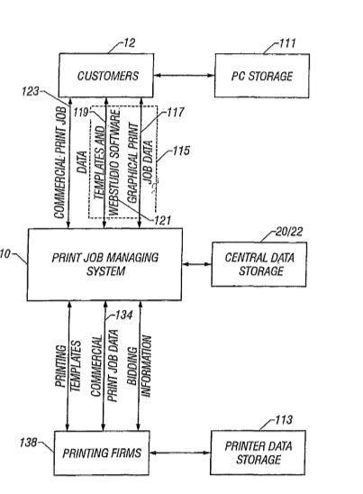

*Figure 1:Print job management system structure(CIMPRESS USA INCORPORATED, Waltham, MA (US), 2016*

This system is by and large beneficial to clients. Since the printer needs to bid for the the cost, clients will have the ability to get a better cost other than when they are working with a steady printer. The client won't be affected by the enlargement of material cost also. From the point of view of the printer, this open system may challenge since there's a shot at losing their normal clients.

2.2 Common quotation generating systems

As demonstrated by the invention of Giovannoli (1996) that the automated quotation producing system resembles a web-based business site at present. A buyer can request a quotation for a particular thing or a list of things by means of the system and a while later the system process it and send to picked merchants through File Transfer Protocol (FTP) or email. Once the sellers get it they send their costs and pertinent points of interest to the system. This is done consequently utilizing software given by the

8

quotation system to every merchant. Merchant software connects with the quotation system on a merchant decided calendar to receive demands for quotation and reacting to them with stock and evaluating data. The quotation system utilizes the merchant's quotations to prepare email for the requesting purchaser. The email can be arranged utilizing html codes to allow the purchaser to show its email as though it were a html page, email reaction will have html. Hypertext ability and empower the purchaser to choose alternatives from the html coded email for the helpful handling of the quotations. Such alternatives may incorporate sending an electronic purchase order in response to a sellers quotation and asking for that suitable credit data of the purchaser be given to the merchant from records kept by the quotation system. Application helper software can be given by the quotation system to system individuals for the advantageous handling of html email reactions. (Giovannoli, 1996) At the moment that a merchant post precise components of a sale items, system itself check for selected buyers and their pre-portrayed tendencies of accepting points of interest of offer things and if any matches system delivers an email and send to buyers itself.

This system is an ordinary structure of quotations creating systems. It will extend the capability of passing on the quotation since it is created by the system itself. Then again there are chances that the merchant might be delayed to react to quotations since it is regularly conveying as an email to the vender.

9

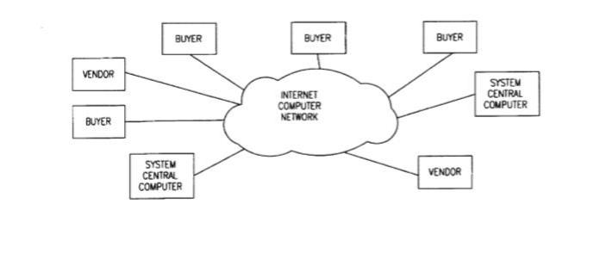

*Figure 2:Common quoting systems-1-outer view (Giovannolli, 1996)*

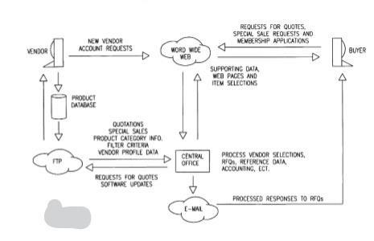

*Figure 3: Common quoting systems-1-how it works; internal view (Giovannolli, 1996)*

As McMahon et.al created in 2001 user (client/buyer) can pick the vender as their tendency and as shown by the user they can change the details of interest of the gear. They can pick decisions for their purchase as given on the site and a while later the site itself will figure the cost. (McMahon, Dovalis and Fogarty, 2001) These sorts of quotation creating systems are for the most part for vehicle leasing and selling. This system works correctly and capably in

10

quotation creating. However, if it is executed in an offset printing firm, it won't empower the client to request a fitting quotation since as far as possible the determinations.

11

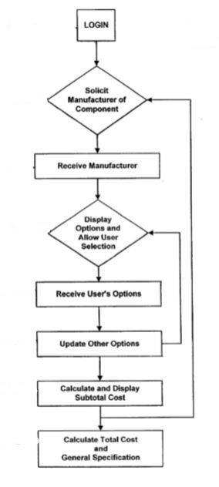

*Figure 4: Flowchart of how the system works (McMahon, Dovalis and Fogarty, 2001)*

Most by far of the previously mentioned fundamental quotations producing systems rely upon the vehicle bargains. Thusly with a particular true objective to realize the proposed system there are various customizations to be finished.

12

2.3 Data Mining

Kaur in 2017 communicated that Data mining consolidates advanced data investigation tools and strategies that used to find substantial patterns, associations and make conjectures among immense data sets. These devices and techniques can be separated into two major classes to be specific predictive and descriptive. The descriptive model perceives patterns and connections in a data set furtherly they investigate the properties of a given data set. While a prescient model predicts obscure data from known and given data. (Kaur, 2017)

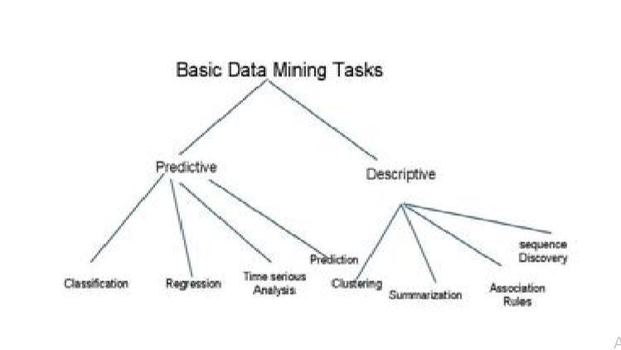

*Figure 5:Data mining categories (Kaur, 2017)*

The proposed system will utilize descriptive data mining methods as beneath since it will enhance the skillfulness of the system.

Association - In association, an example is found based on a connection between things in a similar exchange. That is the motivation behind the association method is otherwise called connection strategy. The association procedure is used in showcase bin examination (market basket analysis) to perceive an arrangement of items that customers regularly purchase together. Retailers use association system to distinguish client's purchasing propensities." (Kaur, 2017)

13

Sequence Discovery - It is one of those data mining strategies that endeavor to discover or perceive comparative patterns, normal occasions or patterns in exchange data over a business period. In sales, with recorded exchange data, organizations can distinguish an arrangement of itemss that customers purchase together at various occasions in a year. At that point organizations can utilize this data to recommend customers get it with better arrangements based on their buying recurrence before." (Kaur, 2017)

Clustering - Is a data mining procedure that makes an important or helpful group of articles that have relative characteristics using the programmed strategy. The clustering procedure characterizes the classes and places questions in each class, while in the classification systems, objects are apportioned to officially characterized classes. It is generally utilized in market surveying, design acknowledgment, image processing and so on." (Kaur, 2017)

Types of progress in headways, for instance, data warehousing, data mining and campaign management software have lead customer relationship management to the other way where associations can get a high ground. Through data mining it has ended up being more compelling and exact the extraction of concealed prescient data from considerable databases, associations can perceive huge clients, figure future practices, and engage firms to make proactive, learning driven decisions. The electronic, future-arranged investigations made possible by data mining. Moreover, the investigations of past events have been given by history-oriented tools, for instance, decision support systems. Data mining gadgets that tended to business request in the past were monotonous. Eventhough, it is the reaction to these request makes client relationship administration possible. There are distinctive techniques among data

14

mining programming, each with their own particular positive conditions and challenges for different sorts of employments. (Rygielski, Wang and Yen, 2002)

Challenge is to perceive the most suitable technique for the proposed framework.

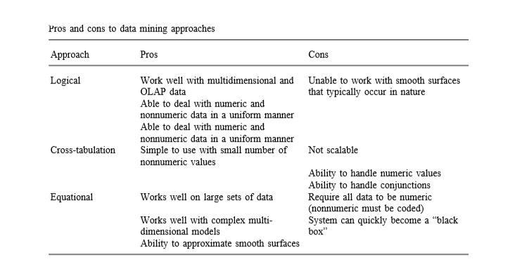

*Figure 6:Pros and Cons in data mining approaches (Rygielski, Wang and Yen, 2002)*

2.4 Customer Relationship Management

Customer Relationship Management is defined by four components of a straightforward system: Know, Target, Sell, Service "(Rygielski, Wang and Yen, 2002). The fundamental motivation behind having a CRM in an organization is to recognize its business sectors and clients. Counting distinguishing the most beneficial clients and the individuals who are never again worth focusing on.

In the perspective of the proposed system, it is fundamentals to keep up client connections effectively. It also includes the advancement of the offer: when choosing "which items to pitch to which clients and through which channel" (Rygielski, Wang and Yen, 2002). The proposed system incorporates a facility of telling the client when

15

the quotation asks for is conveyed to the capable individual and will stay in contact with the client until the request is finished.

Currently there are different kinds of CRM soft wares available in the market. Several examples are shown below.

**2.4.1. HUB SPOT CRM:** It is a free application that still packs a punch with regardsto hearty and viable highlights. These functionalities incorporate web-based life (social media), altered perspectives, organization database, intuitive(drag and drop) communicator, and website, telephone, and email joining. You can begin with this application rapidly and require not change your current work process. The item offers the fundamental essential highlights and does not mistake users for complex fancy odds and ends. Consequently, it is appropriate for little and expansive organizations in any industry and specialty. The product is accessible for nothing so you can undoubtedly give it a shot." (Hillsberg, 2018)



*Figure 7::Hubspot logo*

16

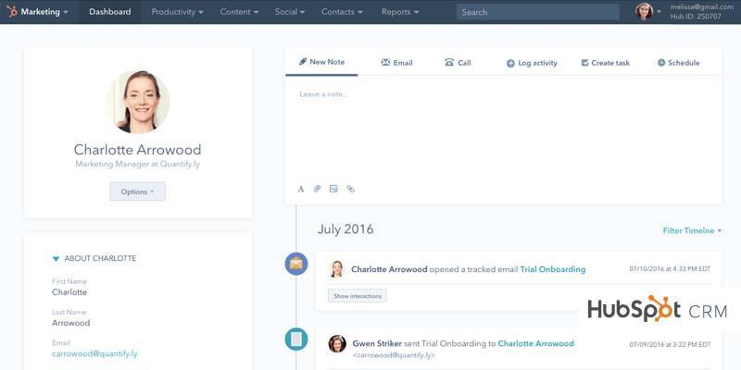

*Figure 8:Hub spot GUI*

**2.4.2 PIPEDRIVE:** This is another phenomenal CRM choice and a solid contenderon the rundown of 10 best CRM software tools. It composes your leads in a way that gives you a reasonable diagram of your business procedure and enables you to center around critical arrangements. Additionally, you can use this answer for productively deal with your association's business pipeline. Indeed, you can turn modules on and off according to your necessities with no impact on your administration quality. Key highlights incorporate sales detailing, timetable view, straightforward data import and export, contact history, and email reconciliation. (Hillsberg, 2018)



*Figure 9:Pipe drive logo*

17

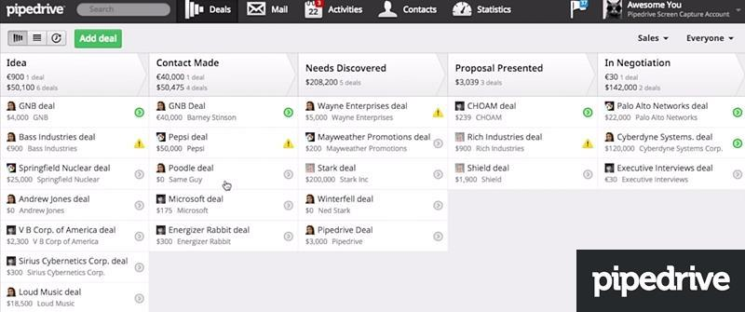

*Figure 10:Pipe drive GUI*

The proposed system will incorporate a portion of the CRM includes as it is centered around automated quotation creating technique.

2.5 Similar Systems

Together with CRM arrangements, there are much web-based Quoting software accessible. The vast majority of them can be downloaded free and some of them are to be purchased. When you get the product in your PC/office network, they can be redone as per user's inclinations.

18

To be contrasted with the proposed system three of the most prominent quoting software are chosen.

**2.5.1 BITRIX24**

Bitrix24 is a free CRM with boundless statements and solicitations. Not at all like other free quotation receipt arrangements, Bitrix24 statements and solicitations are completely adjustable and accompanied ground-breaking instruments, similar to multiple currency support, taxes, programmed numbering, item inventory, product catalog and email promoting. (Bitrix24.com, 2018)



*Figure 11:Bitrix24 logo*

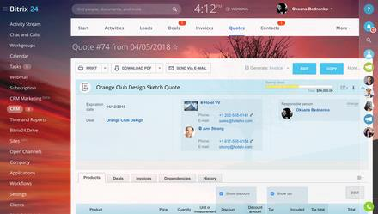

*Figure 12:Bitrix24-quote generaing GUI*

19

CRM is another element of this product. Yet, to be refreshed about a quotation, the user needs to independently speak with the client. This product is primarily centered around the server end tasks.

**2.5.2 XERO**



*Figure 13: Xero logo*

Send proficient looking statements utilizing our customizable format. Just fill in your points of interest, transfer your logo and pick a subject to suit your business. In the event that you incline toward, you can change quotes to estimates.

With Xero, you can distinguish quotes that have been conveyed and check whether they've been seen. Utilize online quotets to see whether they've been acknowledged or in the event that you have to follow up.

20

Forthcoming clients can acknowledge, decay or remark on the quotation with the click of a button. Effortlessly alter and resend a quotation if you have to. Save time and stay away from data entry errors by utilizing online quotes in Xero to make invoices. Making a receipt pulls in every one of the subtle elements straightforwardly from the quotationt. You can alter, add and remove things as important. Disentangle the procedure, decrease the measure of time you spend on administrator and will probably get paid on time." (Xero, 2018)

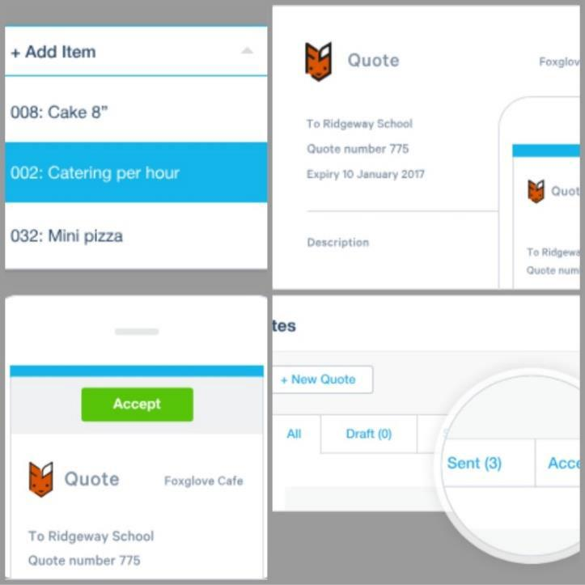

*Figure 14: Xero-features*

This product incorporates the component of telling when the client sees the quotation and furthermore it can create the receipt through the quotation. In any case, it can utilize just the information which user has embedded into Xero. However, it is likewise centered more about the server end assignments.

21

**2.5.3 QUOTIENT**



*Figure 15:Quotient logo*

This product incorporates numerous highlights that can be utilized by both the customer and the server. Once you've created the quotations it can be sent to the customer by means of email and both can develop a discussion on the quotation by means of a web based talking methodology (online chatting) and adjustments can be done effectively. Likewise, it makes simple for the client to acknowledge or decline the quotation basically by clicking a button in the quotation. Additionally, the server will be informed when the customer has seen the quotation. (Quotientapp.com, 2018)

22

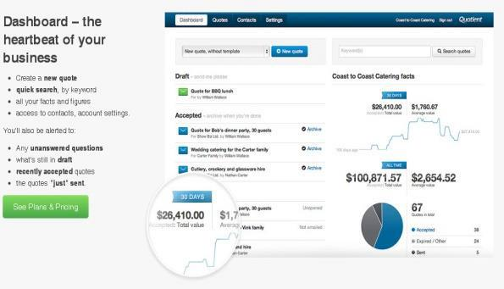

*Figure 16:dashboard GUI-Quotient*

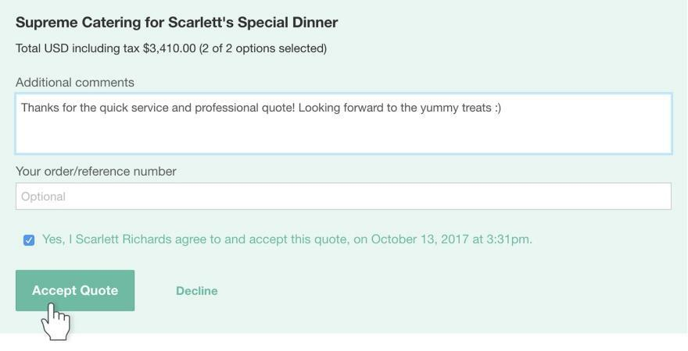

*Figure 17: acceptance One-time: Quotient*

This software includes many similar features as the proposed system but yet most of it based on the server end tasks and use the data which were fed into the system only.

2.6 Research Significance

This examination was done in 4 primary regions. Chiefly considering Quotation generating in the printing industry and in like manner, Data mining and CRM. As of the at first recognized requirements of the proposed system, it ought to be incorporated numerous qualities from the previously mentioned classifications. i.e. The proposed system will be a compound adaptation of the delicate products and strategies said above.

23

The table below shows the comparison between the proposed and existing software.

*Table 2-0-1 comparison table*

|  |  |  |  |  |  |  |  |  |
| --- | --- | --- | --- | --- | --- | --- | --- | --- |
| **Functionality** | | | | **Bitrex24** | **Xero** | **Quotient** | **Proposed** |  |
|  |  |  |  |  |  |  | **system** |  |
|  |  | |  |  |  |  |  |  |
| Customer | can | | request | **×** | **×** | **×** | √ |  |
| quotations via the system. | | | |  |  |  |  |  |
|  |  |  |  |  |  |  |  |  |
| Manager | will | be | notified | **×** | **×** | **×** | √ |  |
| when a customer requests a | | | |  |  |  |  |  |
| quotation. |  |  |  |  |  |  |  |  |
|  | | | |  |  |  |  |  |
| Generate automated quotation | | | | **×** | **×** | **×** | √ |  |
|  | | | |  |  |  |  |  |
| Send quotation to client | | | | √ | √ | √ | √ |  |
|  |  |  |  |  |
|  | |  | |  |  |  |  |  |
| Notify manager | | when client | | **×** | √ | √ | **×** |  |
| viewed the email. | | |  |  |  |  |  |  |
|  | | | |  |  |  |  |  |
| Client can accept via the | | | | **×** | **×** | √ | **×** |  |
| system |  |  |  |  |  |  |  |  |
|  | |  | |  |  |  |  |  |
| Notify manager | | when client | | **×** | √ | √ | √ |  |
| accepted. |  |  |  |  |  |  |  |  |
|  | |  |  |  |  |  |  |  |
| Create invoice | |  |  | √ | √ | √ | √ |  |
|  |  |  |  |  |
|  |  |  |  |  |  |  |  |  |

24

|  |  |  |  |  |  |
| --- | --- | --- | --- | --- | --- |
| Pay online | √ | √ | √ | **×** |  |
|  |  |

After furtherly considering the recommended areas of the proposed system, it has had an extraordinary effect on the proposed system. They can be utilized to distinguish the system limits and to make new prerequisites. The analyst is expected to build up ‘customized web based software for customer handling in L.N.D. Graphics (PVT) Ltd’ including the new discoveries of this investigation.

25

3.Methodology

3.1 Methodology

**3.1.1 Introduction to methodology**

The proposed

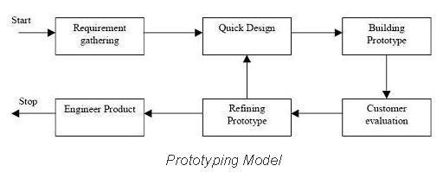

system

belongs to the

category of

ERP systems.

Since it is an alternative to an existing system it should be eventually tested. Before

releasing the final product, it is essential to get the users’ feedback and add

enhancements to the system where possible.

Therefore, the proposed system will be developed using the Prototype methodology.

**3.1.2 Prototype methodology**

The prototyping model is a system creating strategy in which a prototype of the system is manufactured and tried for a few times until the point that a worthy outcome is finally accomplished, and the entire system can be executed.

26

*Figure 18:Overview of prototype model (Google.lk, 2018)*

**3.1.3 Benefits of Prototype methodology**

When there’s a chance of changing requirements and adding more which has not been clearly identified at the initial stage this model is used. It is an iterative, experimentation process that happens between the engineers and the users. (SearchCIO, 2018). Therefore, the prototype is being refined eventually. It is easy to add a

new function in the midst of the designing process and changes can be applied without a higher cost and a time wasting.

**3.1.4 Application of the prototype model**

Regardless of the actual behavior of selected methodology when considering the time of the complete project, this system will have only one prototype version. After testing the prototype in a real-life environment with the actual company and analyzing customer’s feedback the final product will be released after the refinements.

3.2 Planning

**3.2.1 Current Plan and the progress**

Planning phase of the project was done at the beginning of the project. With a basic idea of the proposed project planning was started. During it the WBS and the Gantt chart are prepared.

27

When preparing the WBS project is divided into 4 main parts according to SDLC.

* Planning – Main work plan of the system and as a preparation a study on data mining strategies was done.

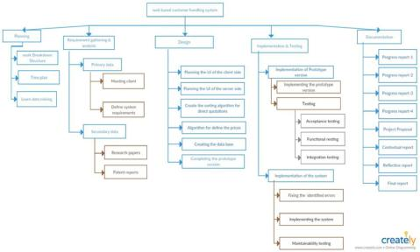

* Requirement gathering and analysis- Gathering primary and secondary data and analyze to get an idea of the system.
* Designing – Main parts of the system , GUIS, algorithms are created.
* Implementation and testing- Prototype version and the final product will be implemented and tested.

Gantt chart was initially created found with it where it was not

at the beginning of the project. Some issues were according to correct dates. A

*Figure 19:WBS*

28

new Gantt chart is created accordingly and had to execute work plan according to it.(

The recreated Gantt chart can be found in Appendix -A)

**3.2.2 Future Plan**

After the proposed system is implemented in the company a frequent feedback session is planned to be done until the company and its customers are used to the system. If it is found that the system has no more features to be added, as the next step the developer is determined to develop this software which can be used in similar kind of organizations. i.e. To develop this as a quotation generating application which can be adopted to other companies too.

3.3 Requirement Gathering & Analysis

Requirement gathering, and analysis is the most important phase since the proposed system will be an alternative for an existing manual process.

In order to gather primary information, the manager and two employees who handle the quotations were interviewed. They each were given a questionnaire in order to gather relevant information. (Questionnaire can be found in Appendix -B) By analyzing their answers and after further discussion with the Manger requirements were finalized.

29

*Table 3-0-1 Functional Requirements*

|  |  |  |  |  |  |  |  |
| --- | --- | --- | --- | --- | --- | --- | --- |
| **Functional** | **Input** |  | **Output** |  | **Process** |  |  |
| **requirement** |  |  |  |  |  |  |  |
|  |  |  |  |  |  | | |
| F1: Request quotations | Product |  | Generated | quote | Enter all the details | | |
|  | details, |  | request. |  | via a GUI and get a | | |
|  | sample file |  |  |  | properly | created | |
|  |  |  |  |  | quotation request. | | |
|  |  |  |  |  |  | |  |
| F2: Send quotations by | System |  | An | email | Automatically | |  |
| email | generated |  | mentioning | the | send customer | | an |
|  | request |  | quotation | request | email. |  |  |
|  |  |  | along with the | |  |  |  |
|  |  |  | sample file |  |  |  |  |
|  |  |  |  |  |  |  |  |
| F3: Create quotation | System |  | Quotation | created | Getting | all | the |
|  | generated |  | for the request. | | primary | costings | |
|  | details, final | |  |  | and enter final few | | |
|  | costings, |  |  |  | amounts |  | and |
|  | customer |  |  |  | finalize the cost. | | |
|  | ratings, |  |  |  |  |  |  |
|  |  |  |  |  |  |  |  |
|  |  | 30 | |  |  |  |  |

|  |  |  |  |  |
| --- | --- | --- | --- | --- |
| F4: Send to customer | Quotation | Email | Send email to the | |
|  |  |  | customer | who |
|  |  |  | requested. |  |
|  |  |  |  |  |

Most common non-functional requirements such as Security, Reliability, Usability and Performance were identified as system’s non-functional requirements.

Secondary information was gathered using WWW. Research papers, patent papers, journals, conference papers were gathered using google scholar. Books on data mining, data science used to learn data science and data mining. You tube tutorials, W3 schools , tutorials point, GitHub, were used as guide lines in developing the system.

3.4 Design

This is the most important phase of developing. System was designed in order to fulfil the requirements. This task was done in 3 sub phases.

**3.4.1 System Design**

Firstly, the use case diagram was created to refine the system and its tasks for particular actors.

31

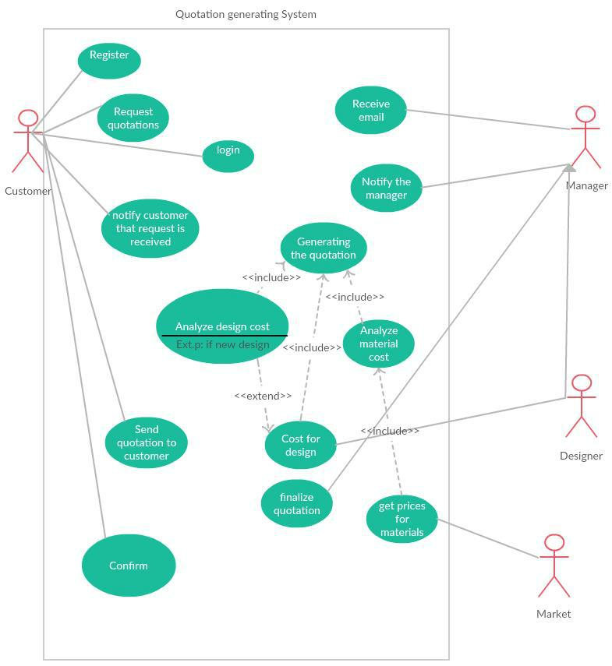

*Figure 20:Use case diagram*

32

High-level architecture diagram gives an overall idea of the system.

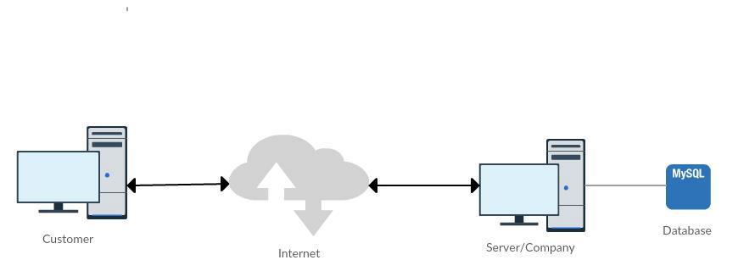

*Figure 21 High-level architecture diagram*

**3.4.2 Interface Design**

System is mainly controlled via interfaces. Interfaces were designed to manage the system properly. They all were created using Bootstrap framework and in PhpStorm IDE.

33

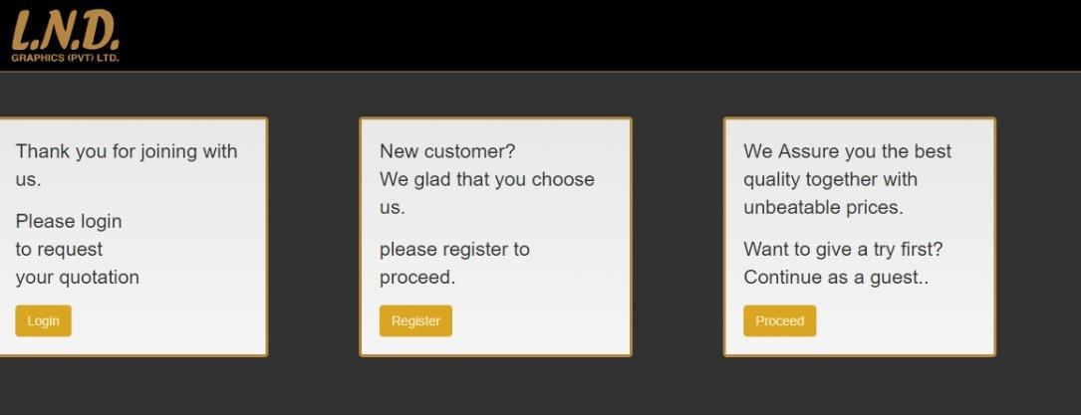

*Figure 22: Home GUI*

If a regular customer, you can login to the system using the login button.

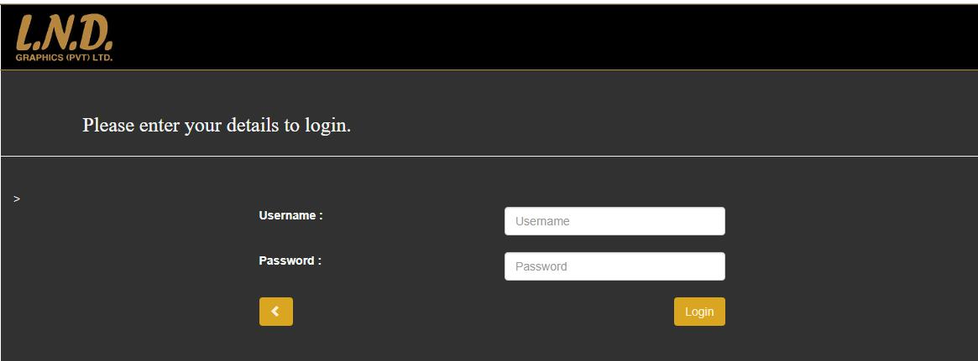

*Figure 23: Login GUI*

34

When successfully logged customer can enter details to request the quotation.

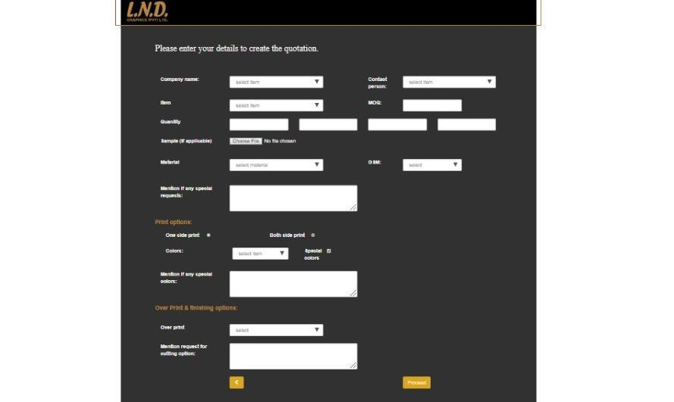

*Figure 24:Request quotationGUI-regular customer*

After entering details A preview of the quotation will be displayed.

35

If customer wants to continue as a guest he will be directed to request quotation at

once.

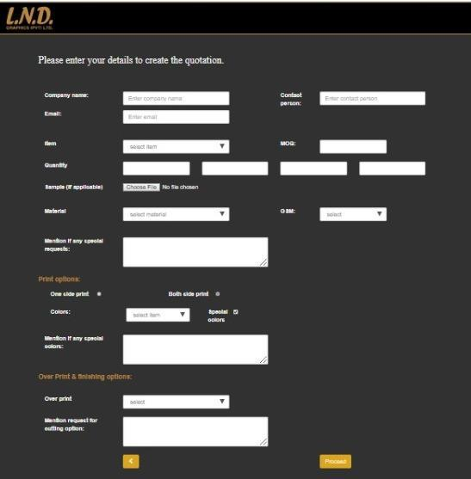

*Figure 25: Request quotationGUI-guest*

36

If customer would like to register ,After clicking “REGISTER” in home page he will be directed to enter company details.

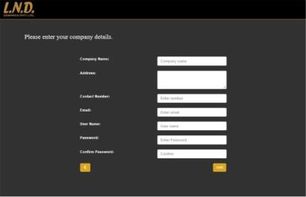

*Figure 26:Enter compant detailsGUI*

37

After That he will be prompted to enter contact details.

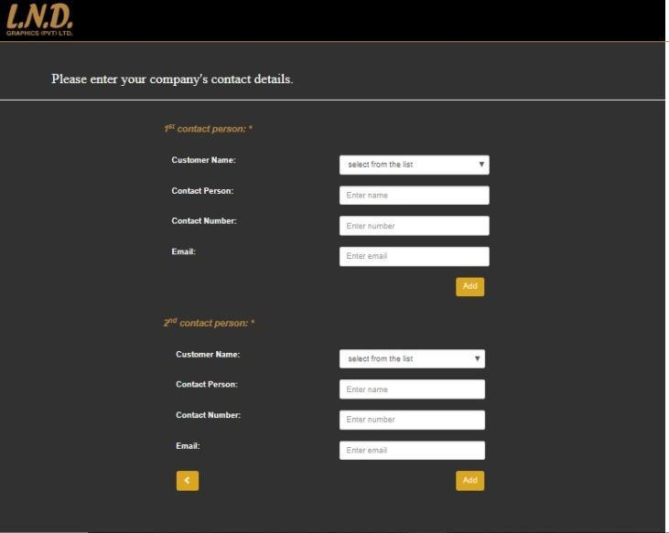

*Figure 27: Customer Contact details GUI*

38

**3.4.3 Database Design**

This system is mainly depended on data. Therefore, maintaining a proper DB is essential. Beforehand the ER map was created after gathering requirements.

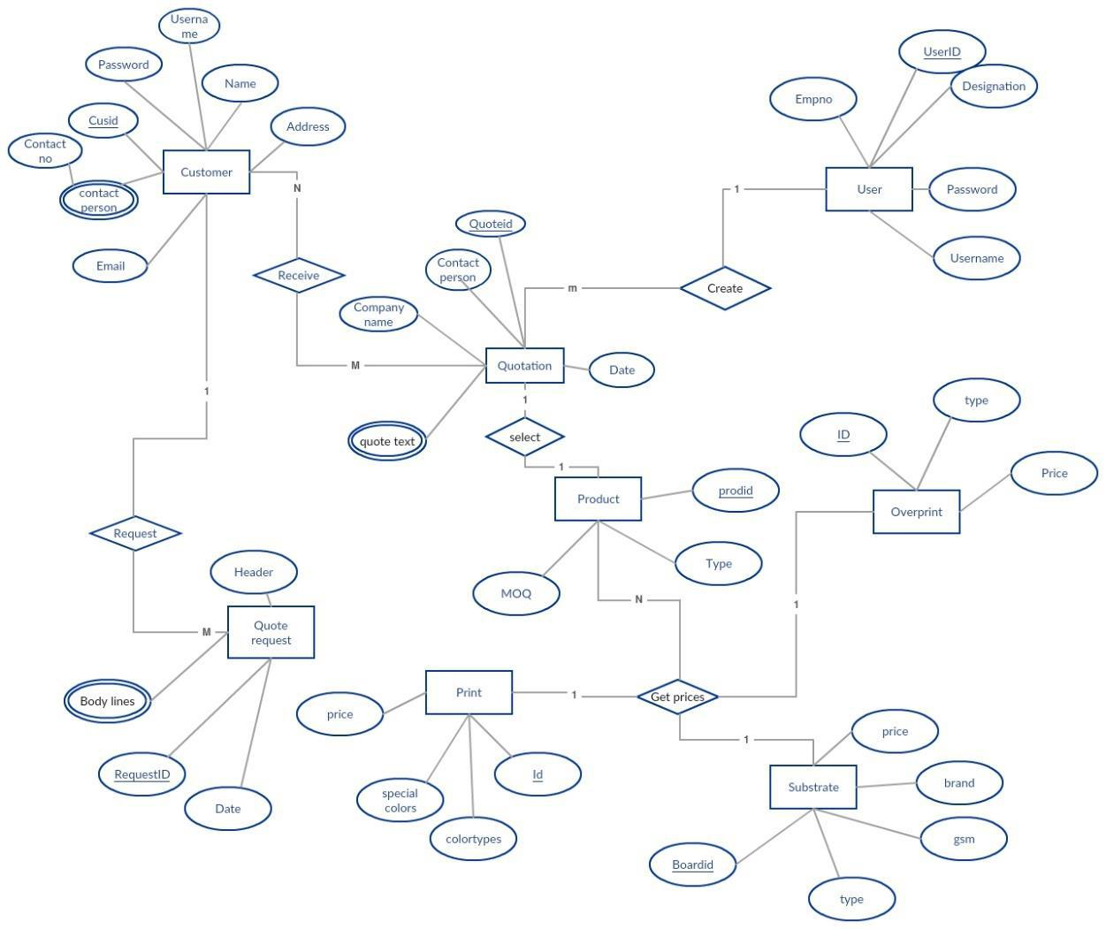

*Figure 28: ER diagram*

3.5 Implementation

This chapter will include all the details about the implementation and further it will include code segments.

39

**3.5.1 Technology used**

During implementation phase several technologies and soft wares were used.

* **PHP**

Most parts of the system will be web based therefore PHP is the language which is used to develop the system. PHP is one of the widely used general-purpose scripting language. (W3schools.com, 2018) Moreover it can be embedded into HTML without having many codes to output the HTML in our web-page. The specialty of php is that the code is executed on the server and user will get the generated HTML as the result. (Php.net, 2018)

When developing the proposed system Php is also used to develop the whole server-side process. While using its many features such as form handling, working as an CGI processor, generate dynamic page content and compatibility with any OS and a web browser.

* **PhpStorm**

The IDE which is used to develop the system. It is one of the most convenient Ides provided by JetBrains. It includes features of Smart code navigating, Easy refactoring, on time error prevention, debugging and unit testing too.

40

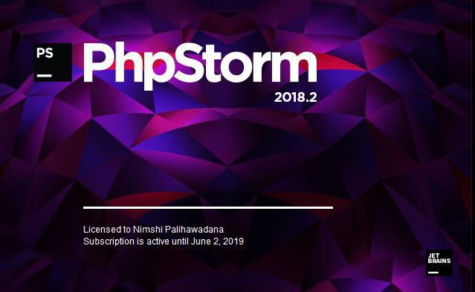

*Figure 29: PhpStorm*

* **Bootstrap**

Bootstrap is a front-end framework including HTML and CSS based design templates for typography, tables, navigation, forms, buttons and many other together with optional JavaScript plugins. Responsive web designs can be easily created using Bootstrap.

* **WAMP server & My SQL**

This is the web development platform used to develop the project. Everything needed to develop a web application is automatically installed by Wamp server. Server settings are managed by this. It will access the logs and the setting files. Will use VirtualHost as hosters. (SourceForge, 2018)

41

Mainly wamp server manages Apache, MySQL and MariaDB services. Therefore MySql is selected as the database of the system which will be controlled through PHP my admin software.

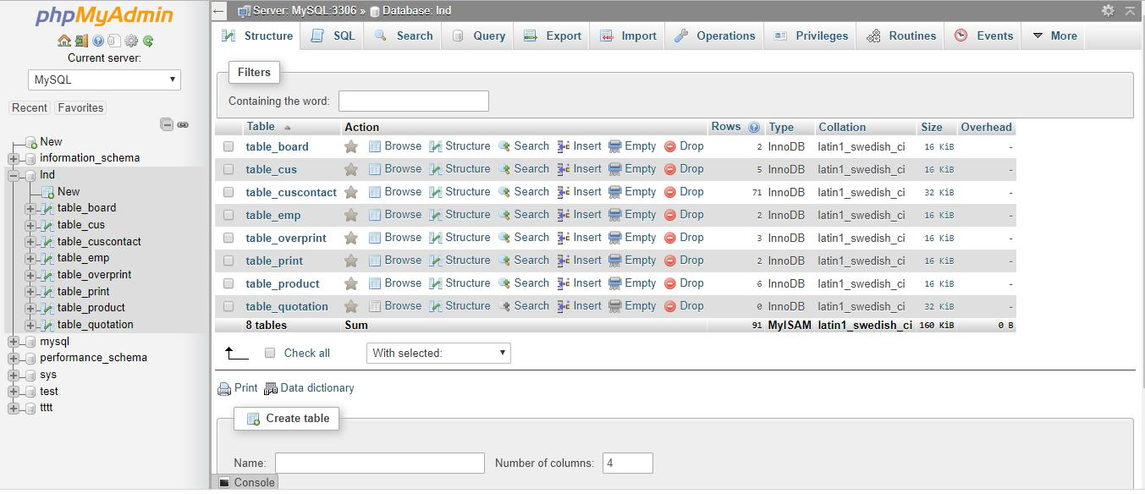

*Figure 30: Screenshot of PhpMyAdmin*

**3.5.2 Code segments**

Boots strap was included in the system by using the CDN (Content Delivery network). Which will help user to experience faster browsing. And also JQuery is included in order to use javascript plug-ins.

<head>

<meta charset="UTF-8" name="viewport" content="width=device-width, initial-scale=1">

<title>CustomerContact</title>

<!-- Latest compiled and minified CSS --> <link rel="stylesheet"

href="https://maxcdn.bootstrapcdn.com/bootstrap/3.3.7/css/bootstrap.min.css

* integrity="sha384-BVYiiSIFeK1dGmJRAkycuHAHRg32OmUcww7on3RYdg4Va+PmSTsz/K68vbdEjh4u" crossorigin="anonymous">

<!-- Optional theme -->

<link rel="stylesheet"

href="https://maxcdn.bootstrapcdn.com/bootstrap/3.3.7/css/bootstrap-

theme.min.css" integrity="sha384-

rHyoN1iRsVXV4nD0JutlnGaslCJuC7uwjduW9SVrLvRYooPp2bWYgmgJQIXwl/Sp"

crossorigin="anonymous">

42

<script

src="https://code.jquery.com/jquery-3.3.1.js"

integrity="sha256-2Kok7MbOyxpgUVvAk/HJ2jigOSYS2auK4Pfzbm7uH60="

crossorigin="anonymous"></script>

<!-- Latest compiled and minified JavaScript --> <script

src="https://maxcdn.bootstrapcdn.com/bootstrap/3.3.7/js/bootstrap.min.js"

integrity="sha384-

Tc5IQib027qvyjSMfHjOMaLkfuWVxZxUPnCJA7l2mCWNIpG9mGCD8wGNIcPD7Txa"

crossorigin="anonymous"></script>

<link rel="stylesheet"

href="https://maxcdn.bootstrapcdn.com/bootstrap/3.3.7/css/bootstrap.min.css

">

<script

src="https://ajax.googleapis.com/ajax/libs/jquery/3.3.1/jquery.min.js"></sc

ript>

<script

src="https://maxcdn.bootstrapcdn.com/bootstrap/3.3.7/js/bootstrap.min.js"><

/script>

<style>

.jumbotron {

background-color: #313131;

color: whitesmoke;

}

.bg-up {

background-color: black;

color: #b68640;

background-size: auto;

}

.btn-lnd{

background-color: goldenrod;

color: papayawhip;

}

.hr {

display: block;

margin-top: 0px;

margin-bottom 0px;

border-style: inset;

border-width: 1px;

border-color: #b68640;

}

</style>

</head>

This header is included in every .php file and Bootstrap has the facility to create customized classes in order to maintain a unique style and CSS STYLES can be used in them.

43

Each .php file is connected with the DB

**<?php**

$servername = "localhost";

$username = "root";

$password = "";

$DBname="lnd";

$conn = **new** mysqli($servername, $username, $password,$DBname);

**if**($conn->connect_error){

**die**("Connectionfailed:".$conn->connect_error);

}

**echo**"Connectedsuccessfully"."\n";

**?>**

This system is based on GUIs and the task are done between them. In order to maintain a proper uniformity the pages are designed Division vised. As an example the code of the simplest GUI is given below.

<!DOCTYPE html>

<html lang="en">

<head>

<meta charset="UTF-8">

<title>Company details</title>

<meta charset="UTF-8" name="viewport" content="width=device-width, initial-scale=1">

<title>CustomerContact</title>

<!-- Latest compiled and minified CSS --> <link rel="stylesheet"

href="https://maxcdn.bootstrapcdn.com/bootstrap/3.3.7/css/bootstrap.min.css

* integrity="sha384-BVYiiSIFeK1dGmJRAkycuHAHRg32OmUcww7on3RYdg4Va+PmSTsz/K68vbdEjh4u" crossorigin="anonymous">

<!-- Optional theme -->

<link rel="stylesheet"

href="https://maxcdn.bootstrapcdn.com/bootstrap/3.3.7/css/bootstrap-

theme.min.css" integrity="sha384-

rHyoN1iRsVXV4nD0JutlnGaslCJuC7uwjduW9SVrLvRYooPp2bWYgmgJQIXwl/Sp"

crossorigin="anonymous">

<script

src="https://code.jquery.com/jquery-3.3.1.js"

integrity="sha256-2Kok7MbOyxpgUVvAk/HJ2jigOSYS2auK4Pfzbm7uH60="

crossorigin="anonymous"></script>

<!-- Latest compiled and minified JavaScript --> <script

src="https://maxcdn.bootstrapcdn.com/bootstrap/3.3.7/js/bootstrap.min.js"

44

integrity="sha384-

Tc5IQib027qvyjSMfHjOMaLkfuWVxZxUPnCJA7l2mCWNIpG9mGCD8wGNIcPD7Txa"

crossorigin="anonymous"></script>

<link rel="stylesheet"

href="https://maxcdn.bootstrapcdn.com/bootstrap/3.3.7/css/bootstrap.min.css

">

<script

src="https://ajax.googleapis.com/ajax/libs/jquery/3.3.1/jquery.min.js"></sc

ript>

<script

src="https://maxcdn.bootstrapcdn.com/bootstrap/3.3.7/js/bootstrap.min.js"><

/script>

<style>

.jumbotron {

background-color: #313131;

color: whitesmoke;

}

.bg-up {

background-color: black;

color: #b68640;

background-size: auto;

}

.btn-lnd{

background-color: goldenrod;

color: papayawhip;

}

.hr {

display: block;

margin-top: 0px;

margin-bottom 0px;

border-style: inset;

border-width: 1px;

border-color: #b68640;

}

.well-my{

color: #313131;

border-color: #b68540;

border-radius: 4px;

border-width: 3px;

}

</style>

</head>

<body>

**<?php**

$servername = "localhost";

$username = "root";

$password = "";

$DBname="lnd";

$conn = **new** mysqli($servername, $username, $password,$DBname);

**?>**

<header>

45

<div class="container fluid bg-up" >

<div class="row">

<div class="col-sm-3">

<img src="logo.png" alt="logo"></div>

<div class="row hr">

</div>

</div>

</div>

</header>

<div class="container fluid jumbotron " style="">

<div class="row">

<div class="col-md-3">

<div class="span12">

<div class="row">

<div class="span4">

<div class="well well-my">

<p>Thank you for joining with us.</p>

<p> Please login<br>

to request<br>

your quotation</p>

<a href="LoginUI.php" class="btn btn-lnd"

type="submit"> Login </a>

</div>

</div>

</div>

</div>

</div>

<div class="col-sm-1"></div>

<div class="col-md-3">

<div class="span12">

<div class="row">

<div class="span4">

<div class="well well-my">

<p> New customer?<br>

We glad that you choose us.</p>

<p> please register to proceed.

</p>

<a href="InputCompanyDetailsUI.php" class="btn btn-lnd" type="submit"> Register </a>

</div>

</div>

</div>

</div>

</div>

<div class="col-sm-1"></div>

<div class="col-md-3">

<div class="span12">

46

<div class="row">

<div class="span4">

<div class="well well-my">

<p>We Assure you the best quality together

with unbeatable prices.</p>

<p>Want to give a try first?<br>

Continue as a guest..</p>

<a href="GuestRequestUI.php" class="btn btn-lnd" type="submit" > Proceed </a>

</div>

</div>

</div>

</div>

</div>

</div>

</div>

</body>

</html>

In order to maintain coding standards, proper indentation and naming criterions used.

47

4. Testing and results

4.1 Testing methods

Several testing procedures were done during the time period of the project.

First testing method was user acceptance testing which was taken place after requirement gathering. Due to the tough time plan and work load, only black box testing was done, and functional requirements were identified and finalized.

Integration testing was taken place during the first prototype development phase. After analyzing the results obtained and the feedback from customer, the final version was created.

System testing will be done finally when the system is completed and integrated.

Functionality testing is done in order to check the functions of this system works properly. The test cases and their results are shown below.

4.2 Test cases

*Table 4-0-1Test case-01*

|  |  |  |  |  |
| --- | --- | --- | --- | --- |
| Test Case - ID | User login - TC_1.1 | |  |  |
|  |  |  |  |  |
| Description | Enter | relevant | username | and |
|  | password | |  |  |
|  |  | |  |  |
| Test Procedure | Click login button | |  |  |
|  |  |  |  |  |

48

|  |  |
| --- | --- |
| Test Data | User name field is empty |
|  |  |
| Expected Result | Message:”Please fill out this field” |
|  |  |
| Actual Result | Same as expected |
|  |  |
| Status | Pass |
|  |  |
|  |  |

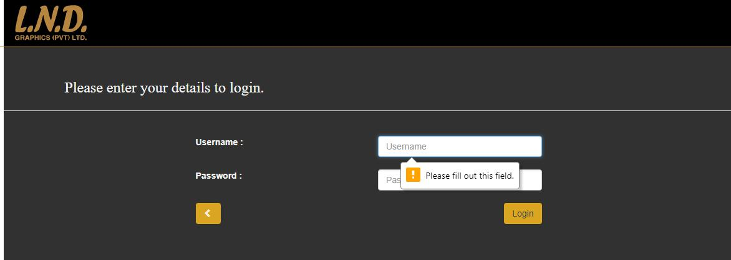

|  |  |  |
| --- | --- | --- |
|  | *Table 4-0-2Test case-02* | |
|  |  |  |
| Test Case - ID |  | User login - TC_1.2 |
|  |  |  |
| Description |  | Enter relevant username and password |
|  |  |  |
| Test Procedure |  | Click login button |
|  |  |  |
| Test Data |  | Password field is empty |
|  |  |  |

49

|  |  |
| --- | --- |
| Expected Result | Message:”Please fill out this field” |
|  |  |
| Actual Result | Same as expected |
|  |  |
| Status | Pass |
|  |  |
|  |  |

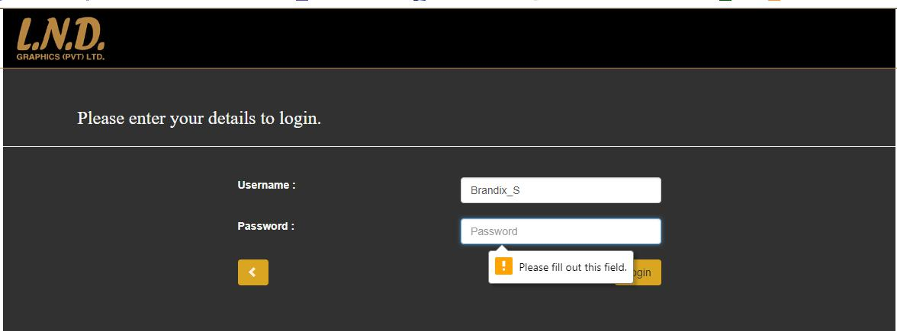

|  |  |  |
| --- | --- | --- |
|  | *Table 4-0-3Test case-03* | |
|  |  |  |
| Test Case ID |  | User login - TC_1.3 |
|  |  |  |
| Description |  | Enter relevant username and password |
|  |  |  |
| Test Procedure |  | Click login button |
|  |  |  |
| Test Data |  | Correct username and password |
|  |  |  |
| Expected Result |  | Prompt to request GUI |
|  |  |  |
|  | 50 | |

|  |  |
| --- | --- |
| Actual Result | Same as expected |
|  |  |
| Status | Pass |
|  |  |

|  |  |  |
| --- | --- | --- |
|  | *Table 4-0-4Test case-04* | |
|  |  |  |
| Test Case - ID |  | Enter company Details-TC_2.1 |
|  |  |  |
| Description |  | Enter correct company details |
|  |  |  |
| Test Procedure |  | Fill in the form and press Add button |
|  |  |  |
| Test Data |  | All fields are empty |
|  |  |  |
| Expected Result |  | Message:” Please fill out this field” |
|  |  | pop up on first field. |
|  |  |  |
| Actual Result |  | Same as expected |
|  |  |  |
| Status |  | Pass |
|  |  |  |

51

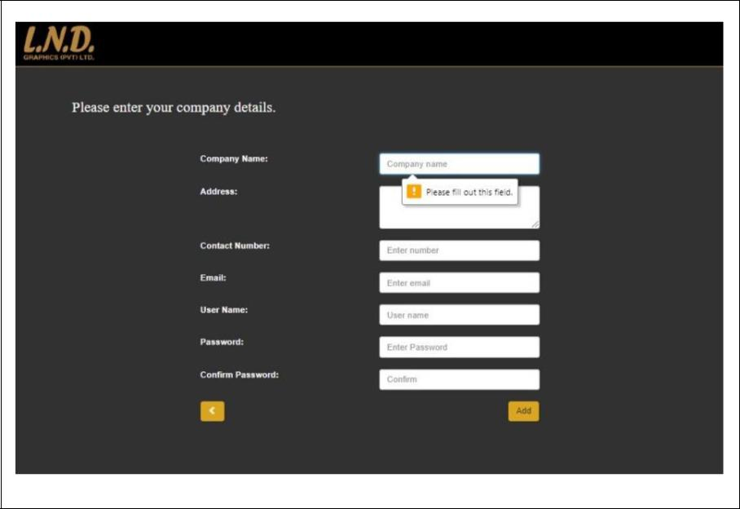

|  |  |  |
| --- | --- | --- |
|  | *Table 4-0-5Test case-05* | |
|  |  |  |
| Test Case ID |  | Enter company Details-TC_2.2 |
|  |  |  |
| Description |  | Enter correct company details |
|  |  |  |
| Test Procedure |  | Fill in the form and press Add button |
|  |  |  |
| Test Data |  | Add wrong format of password |
|  |  |  |
| Expected Result |  | Message: Saying to input proper format. |
|  |  |  |
| Actual Result |  | Same as expected |
|  |  |  |
|  | 52 | |

|  |  |
| --- | --- |
| Status | Pass |
|  |  |
|  |  |

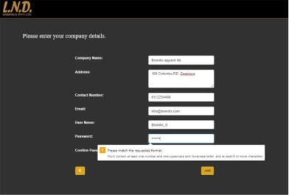

|  |  |  |
| --- | --- | --- |
|  | *Table 4-0-6Test case-06* | |
|  |  |  |
| Test Case ID |  | Enter company Details-TC_2.3 |
|  |  |  |
| Description |  | Entercorrectdetails-Password |
|  |  | validation |
|  |  |  |
| Test Procedure |  | Fill in the form and press Add button |
|  |  |  |
| Test Data |  | Wrong string in the confirm password |
|  |  | field |
|  |  |  |

53

|  |  |
| --- | --- |
| Expected Result | It will be indicating by a red color text |
|  | near the confirm password field. |
|  |  |
| Actual Result | Same as expected |
|  |  |
| Status | Pass |
|  |  |
|  |  |

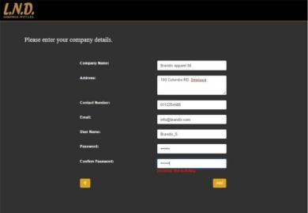

|  |  |  |
| --- | --- | --- |
|  | *Table 4-0-7Test case-07* | |
|  |  |  |
| Test Case ID |  | Enter company Details-TC_2.4 |
|  |  |  |
| Description |  | Entercorrectdetails-Password |
|  |  | validation |
|  |  |  |
|  | 54 | |

|  |  |
| --- | --- |
| Test Procedure | Fill in the form and press Add button |
|  |  |
| Test Data | Correct string in the confirm password |
|  | field |
|  |  |
| Expected Result | It will be indicating by a Green color |
|  | text near the confirm password field. |
|  |  |
| Actual Result | Same as expected |
|  |  |
| Status | Pass |
|  |  |
|  |  |

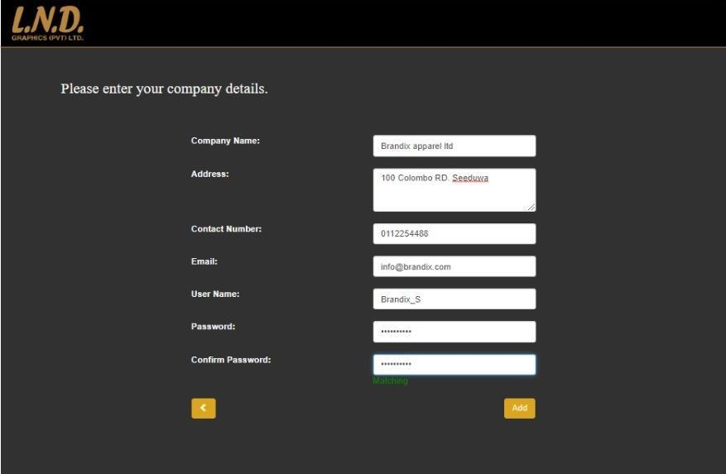

55

|  |  |  |
| --- | --- | --- |
|  | *Table 4-0-8Test case-08* | |
|  |  |  |
| Test Case ID |  | Enter company Details-TC_2.5 |
|  |  |  |
| Description |  | Enter correct details- Email validation |
|  |  |  |
| Test Procedure |  | Fill in the form and press Add button |
|  |  |  |
| Test Data |  | Wrong email address |
|  |  |  |
| Expected Result |  | Message will pop up gving correct |
|  |  | guidelines. |
|  |  |  |
| Actual Result |  | Same as expected |
|  |  |  |
| Status |  | Pass |
|  |  |  |
|  |  |  |

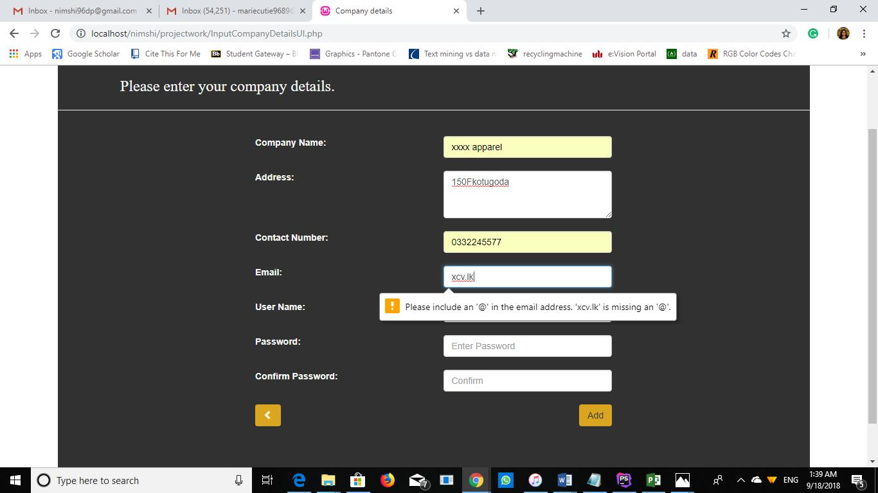

56

|  |  |  |
| --- | --- | --- |
|  | *Table 4-0-9Test case-09* | |
|  |  |  |
| Test Case ID |  | Enter contact Details-TC_3.1 |
|  |  |  |
| Description |  | Enter correct details- empty fields |
|  |  | validation |
|  |  |  |
| Test Procedure |  | Fill in the form and press Add button |
|  |  |  |
| Test Data |  | Empty fields |
|  |  |  |
| Expected Result |  | Message: “Please fill out this field” |
|  |  |  |
| Actual Result |  | Same as expected |
|  |  |  |
| Status |  | Pass |
|  |  |  |
|  |  |  |

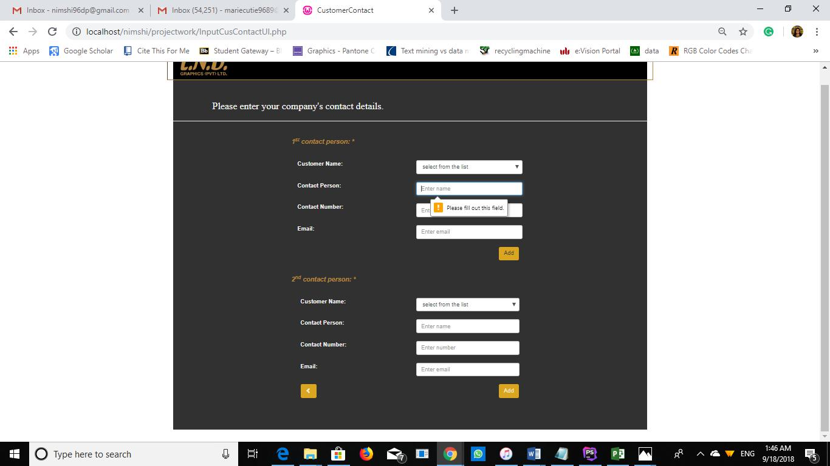

57

|  |  |  |
| --- | --- | --- |
|  | *Table 4-0-10Test case-10* | |
|  |  |  |
| Test Case ID |  | Enter contact Details-TC_3.2 |
|  |  |  |
| Description |  | Enter correct details- Email validation |
|  |  |  |
| Test Procedure |  | Fill in the form and press Add button |
|  |  |  |
| Test Data |  | Wrong email address |
|  |  |  |
| Expected Result |  | Message will pop up giving correct |
|  |  | guidelines. |
|  |  |  |
| Actual Result |  | Same as expected |
|  |  |  |
| Status |  | Pass |
|  |  |  |
|  |  |  |

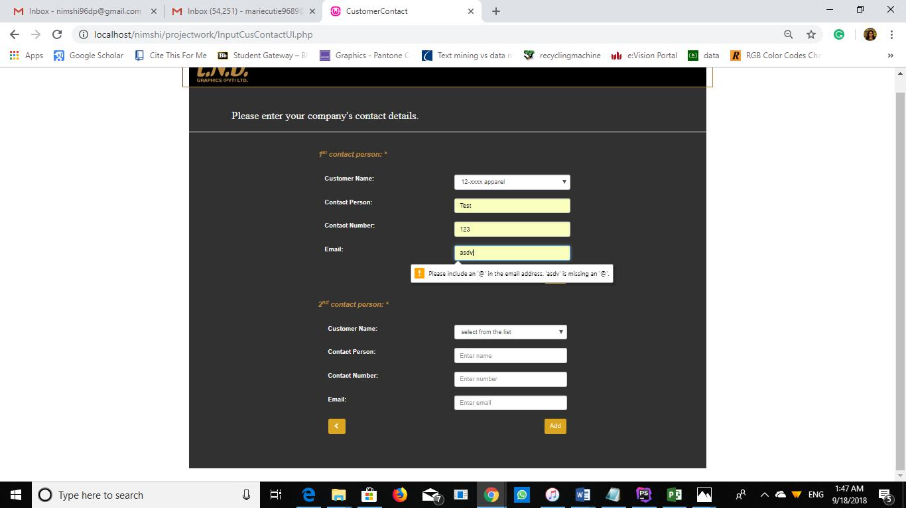

58

5.Evaluation

The evaluation of the proposed system is done with the engagement of the exact client of the project. Since the proposed system is customized and mainly developed to fulfill one’s requirements the best audience for evaluating is its users.

After three days of implementing the system a feedback session was held by giving a questionnaire to manager and the employees and also gathered a feedback from several customers.

Below sums up the feedback of the users at the server end.

*Table 5-0-1 Server side users feedback-summary*

|  |  |  |  |  |  |
| --- | --- | --- | --- | --- | --- |
| **Function** | Very Good |  | Good | Average | Bad |
|  |  |  |  |  |  |
| Receive notification |  |  | ✓ |  |  |
|  |  |  |  |  |  |
| Displaying the quotation | ✓ |  |  |  |  |
| with already fixed |  |  |  |  |  |
| prices. |  |  |  |  |  |
|  |  |  |  |  |  |
| Editing the quotations | ✓ |  |  |  |  |
|  |  |  |  |  |  |
| Add discount with the |  |  | ✓ |  |  |
| ratings of customers |  |  |  |  |  |
|  |  |  |  |  |  |
| Viewing the attached |  |  |  | ✓ |  |
| sample. |  |  |  |  |  |
|  |  |  |  |  |  |
|  |  | 59 | |  |  |

|  |  |  |  |  |
| --- | --- | --- | --- | --- |
| Select materials as |  |  |  | ✓ |
| preference of the |  |  |  |  |
| company |  |  |  |  |
|  |  |  |  |  |
| Send email to the | ✓ |  |  |  |
| customer |  |  |  |  |
|  |  |  |  |  |
| Handling the data base |  |  |  | ✓ |
|  |  |  |  |  |
| Replying for guest users |  |  |  | ✓ |
|  |  |  |  |  |
| Follow up with the |  |  | ✓ |  |
| customer |  |  |  |  |
|  |  |  |  |  |
| Security |  |  | ✓ |  |
|  |  |  |  |  |
| Efficiency |  | ✓ |  |  |
|  |  |  |  |  |

*Table 5-0-2 Server side-suggestions*

|  |  |  |
| --- | --- | --- |
| **Name** | **Designation** | **Comment** |
|  |  |  |
| Mr. L Palihawadana | Managing Director | The idea of the software is good. But |
|  |  | need to be more flexible and ways to |
|  |  |  |
|  | 60 |  |

|  |  |  |
| --- | --- | --- |
|  |  | select from substrate and ink since |
|  |  | we have several suppliers. |
|  |  |  |
| Mr. H. D. Perera | Marketing manager | The idea of notification is really |
|  |  | good. I’m the one who normally |
|  |  | contact customers directly. And they |
|  |  | used to call and remind me that they |
|  |  | sent a request. With this system its |
|  |  | more convenient for me and |
|  |  | customers both. If the system has a |
|  |  | way to have a constant contact and a |
|  |  | way to follow up the customer that |
|  |  | would be great. |
|  |  |  |
| R.J. Fernando | In charge- IT | With this new system it saves time |
|  |  | we spent searching for material |
|  |  | prices. |
|  |  | But it will be better if there is a way |
|  |  | we could enter data to the DB |
|  |  | ourselves. |
|  |  |  |

The customers of the organization are also a part of users of the proposed system. Few customers gave their feedback regarding the new system. Below is the summary of their feedback.

*Table 5-0-3 Client Side users feedback-summary*

|  |  |  |  |  |
| --- | --- | --- | --- | --- |
| **Function** | Very Good | Good | Average | Bad |
|  |  |  |  |  |

61

|  |  |  |  |  |
| --- | --- | --- | --- | --- |
| Register with the system |  | ✓ |  |  |
|  |  |  |  |  |
| Login |  | ✓ |  |  |
|  |  |  |  |  |
| Enter company and |  | ✓ |  |  |
| contact details |  |  |  |  |
|  |  |  |  |  |
| Requesting quotations | ✓ |  |  |  |
|  |  |  |  |  |
| Variety of options |  |  |  | ✓ |
|  |  |  |  |  |
| Uploading files | ✓ |  |  |  |
|  |  |  |  |  |
| Editing the quotation | ✓ |  |  |  |
|  |  |  |  |  |
| Send email to the |  | ✓ |  |  |
| customer |  |  |  |  |
|  |  |  |  |  |
| Getting an |  | ✓ |  |  |
| acknowledgement |  |  |  |  |
|  |  |  |  |  |
| Constant follow up |  |  |  | ✓ |
|  |  |  |  |  |
|  | 62 |  |  |  |

|  |  |  |  |  |
| --- | --- | --- | --- | --- |
| Receiving the email |  | ✓ |  |  |
|  |  |  |  |  |

Below mentioned are some of the ideas they expressed. Since most of them are working with the international market, they requested to the mention their suggestions anonymously in this report.

*Table 5-0-4 Client side user suggestions*

|  |  |
| --- | --- |
| **Customer name** | **Comment** |
|  |  |
| Company 01- Frequent user. | The new way of quotation requesting is |
|  | easier than before. Also, more responsive. |
|  |  |
| Company 02- Frequent user | The new way is easier for both me and the |
|  | supplier, It will be better if you can have an |
|  | option to add multiple items in one request. |
|  |  |
| Company 03 – Moderate user | I’m happy with the new system. But it will |
|  | be better if there’s a way to reset password |
|  | by myself without informing the supplier. |
|  | Since I won’t be frequently logging in. |
|  |  |
| Company 04- Guest user | System looks smart and handy but when a |
|  | person with less knowledge about the |
|  | industry wants to request a quotation it will |
|  |  |
|  | 63 |

be better if you can have a separate format

for them too.

64

6: Conclusion

6.1 Conclusion

This is the final thesis report of the customized web- based software for customer handling at L.N.D. Graphics (PVT) Ltd. It consists of 6 main chapters and the development process of the system is widely discussed throughout the report.

After carefully analyzing the evaluation done, the conclusion which we can make is that the overall project is 80% successful.

At the beginning there were 5 objectives set and they all were achieved by the end of the project. Currently the system has made the quotation generating process easier. It will be more beneficial once the system users get used to work with it.

During the evaluation of the project it is revealed that there are few implicit requirements which couldn’t be fulfilled and the reason for this was lack of time. They are:

* Creating a GUI for the server side to enter prices to the database.
* Being able to select the substrate supplier as the preference of the manager.
* Let users change their password with a simple email validation.
* Having another GUI for customers who do not have a proper idea about the printing industry to send their requests by entering a text and uploading a sample file.
* Let customers enter multiple items for a quotation request.

65

6.2 Limitations

As mentioned in the previous chapter, the proposed system is completed with a 80% of success. From the beginning till end there were few deviations and limitations faced. This chapter will explain about them.

The Gantt chart was created at the beginning of the project. The initial Gantt chart had issues since it was created according to incorrect deadlines and when preparing it by using the software, some fault uses of the working days had occurred. The whole project has to be planned for a time period of 32 weeks. But with this the deadlines were dragged more than the actual deadline. Therefore, a new Gantt chart is created, and the project was conducted according to it. Since The deadlines were shortened, managing time was a challenging task. Somehow by the expected date the final product could be implemented.

Since this system works with a lot of data and data mining was a complete new area of study, more time has to be given on studying data mining and its uses. With the tough time plans the study was conducted in a rush and sometimes there was a risk of missing important facts.

Selecting a proper developing language was one of the main limitations, firstly, the decision was to use JAVA, but as the supervisor suggested it was shifted to Python since Python had more libraries to work with data. In order to work with Python more time was spent on learning Python and the support of a Python developing specialist was taken. As his analysis it was more convenient to develop the system using Php since the amount of data to be mined is not enough. This was the major deviation in

66

the project. More time had to be spent on recreating the GUIs with Php.Finally the tasks were achieved and more than ¾ of the project is successful.

While designing the project it was planned to use real time data syncing and gather prices by connecting to substrate suppliers’ DB. Due to the security reasons and lack of time it could not be executed, and a separate DB was created for the company where the details have to be entered by them.

By managing above mentioned limitations the proposed system is built as better as possible.

6.3 Future work

In previous chapters, the progress of the project is discussed widely.

After adding the enhancements that defined in chapter 6.1 the future goal is to develop this system as a CRM software for the proposed company furtherly allowing to do the online transactions via the system. Where the standards of the organization’s customer handling can be uplifted.

Furtherly, it is planned to develop as a customizable CRM software. i.e. which can be adopted in any similar kind of organization in order to compete with existing softwares like Xero, Quotient, Bitrix42 etc.

67

References

Ainul Azyan, Z., Pulakanam, V. and Pons, D. (2017). Success factors and barriers to implementing lean in the printing industry: a case study and theoretical framework. *Journal* *of Manufacturing Technology Management*, 28(4).

Bitrix24.com. (2018). *Free Quotation And Invoice Software*. [online] Available at: https://www.bitrix24.com/uses/free-quotation-invoice-software.php [Accessed 14 May 2018].

CIMPRESS USA INCORPORATED, Waltham, MA (US) (2016). *Managing Print jobs*.

9645774B2.

Creately.com. (2018). *Creately - Online Diagram Editor - Try it Free*. [online] Available at:

https://creately.com/app/# [Accessed 25 July 2018].

En.wikipedia.org. (2004). *Enterprise* *resource planning*. [online] Available at:

https://en.wikipedia.org/wiki/Enterprise_resource_planning [Accessed 21 June 2018].

Giovannoli, J. (1996). *Computerized quotation system and method*. 5,758,328.

Google.lk. (2018). *Image: What is Prototype model- advantages, disadvantages and when to*

*use* *it?*. [online] Available at:

https://www.google.lk/imgres?imgurl=http://istqbexamcertification.com/wp-

content/uploads/2012/01/Prototype-

model.jpg&imgrefurl=http://istqbexamcertification.com/what-is-prototype-model-

advantages-disadvantages-and-when-to-use-

it/&h=199&w=512&tbnid=gvnQUPctUSL1pM:&tbnh=82&tbnw=211&usg=__rUHmnd6V

2RemI9dXFB67jsG2GUY%3D&vet=10ahUKEwj9puqylZjbAhXMbbwKHSlYCDIQ9QEI

KzAA..i&docid=zFHBCTWZ7H3VvM&sa=X&ved=0ahUKEwj9puqylZjbAhXMbbwKHSl

YCDIQ9QEIKzAA [Accessed 21 June 2018].

68

Han, X., Lei, J., Zhao, X., Luo, P. and Li, J. (2013). Application of Data Mining in CRM. *Applied Mechanics and Materials*, 444-445, pp.1776-1780.

Hillsberg, A. (2018). *List of 10 Best CRM Software Tools - Financesonline.com*. [online] Financesonline.com. Available at: https://financesonline.com/list-10-best-crm-software-tools/ [Accessed 21 June 2018].

Hubspot.com. (2018). *Free CRM for Small Business | HubSpot CRM*. [online] Available at:

https://www.hubspot.com/crm/e010a?utm_content=e010a&utm_source=financesonline.com

&utm_term=crm&utm_campaign=financesonline-

crm&utm_medium=paid_EN&utm_id=e676a [Accessed 18 June 2018].

kaur, H. (2017). A Study On Data Mining Techniques And Their Areas Of Application. *International Journal of Recent Trends in Engineering and Research*, 3(8), pp.93-95.

McMahon, T., Dovalis, M. and Fogarty, M. (2001). *METHOD AND SYSTEM FOR* *AUTOMATING QUOTE GENERATION*. 2001/0034726A1.

OÜ, P. (2018). *Sales CRM &amp; Pipeline Management Software*. [online] Pipedrive.

Available at: https://www.pipedrive.com/?utm_source=FinanceOnline&utm_medium=cpc&utm_campaig n=Homepage [Accessed 18 June 2018].

Php.net. (2018). *PHP:* *What is PHP? - Manual*. [online] Available at:

http://php.net/manual/en/intro-whatis.php [Accessed 17 Sep. 2018].

Quotientapp.com. (2018). *Quotient:* *Quoting* *Software*. [online] Available at:

https://www.quotientapp.com/ [Accessed 18 June 2018].

69

Rygielski, C., Wang, J. and Yen, D. (2002). Data mining techniques for customer relationship management. *Technology in Society*, 24(4), pp.483-502.

SearchCIO. (2018). *What is Prototyping Model? - Definition from WhatIs.com*. [online] Available at: https://searchcio.techtarget.com/definition/Prototyping-Model [Accessed 21 June 2018].

SourceForge. (2018). *WampServer*. [online] Available https://sourceforge.net/projects/wampserver/ [Accessed 17 Sep. 2018].

at:

W3schools.com. (2018). *PHP* *5* *Introduction*. [online] Available at:

https://www.w3schools.com/php/php_intro.asp [Accessed 17 Sep. 2018].

Xero. (2018). *Quotes in Xero | Xero*. [online] Available at: https://www.xero.com/features-

and-tools/accounting-software/quotes/ [Accessed 21 June 2018].

70

Appendix-A (Gantt chart)

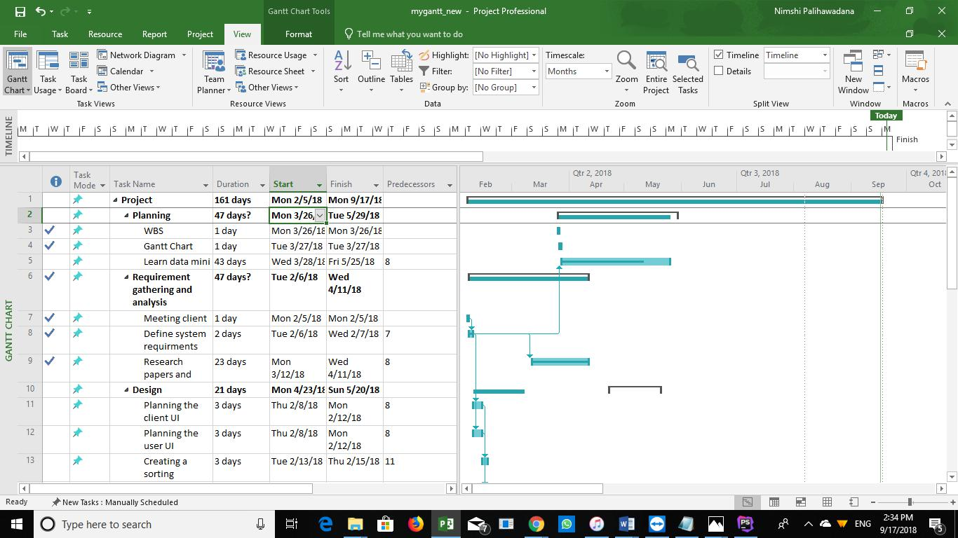

*Figure 31:Gantt chart-1*

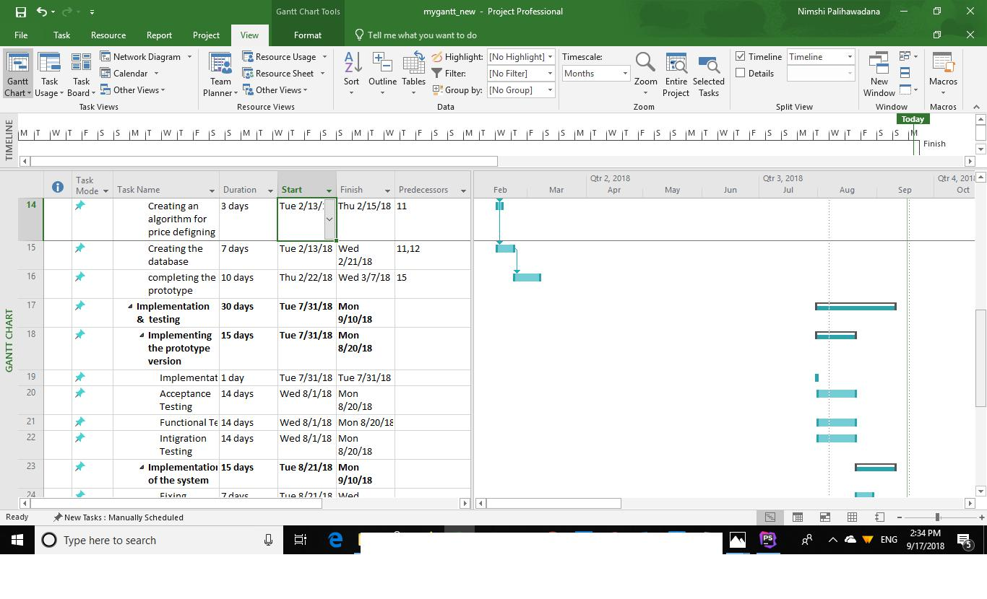

*Figure 32:Gantt chart-2*

71

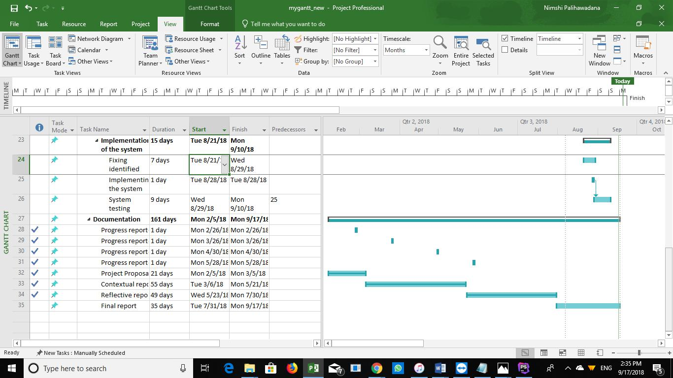

*Figure 33:Gantt chart-3*

72

Appendix-B (questionnaire)

**Questionnaire – Requirement gathering for customized web based system for customer handling at L.N.D. Graphics (PVT) LTD.**

**Name:**

**Designation:**

* As an employee of this company what are the tasks you are assigned to?

………………………………………………………………………………

………………………………………………………………………………

………………………………………………………………………………

………………………………………………………………………………

………………………………………………………………………………

…………………………………………………………………

* Among them what are the tasks that you have to deal with customers?

………………………………………………………………………………

………………………………………………………………………………

………………………………………………………………………………

………………………………………………………………………………

………………………………………………………………………………

…………………………………………………………………

* What are the complaints that you’ve been blamed for most by customers?

………………………………………………………………………………………

………………………………………………………………………………………

………………………………………………………………………………………

………………………………………………………………………………………

………………………………………………………………………………………

………………………………………………………………….

* What are the other tasks do you think that needed an automated system?

73

………………………………………………………………………………

………………………………………………………………………………

………………………………………………………………………………

………………………………………………………………………………

………………………………………………………………………………

………………………………………………………………….

* Do you enjoy working with the current system or do you think you need a separate automated system for quotations?

………………………………………………………………………………

………………………………………………………………………………

………………………….

* What is the hardest part of creating quotations? Why?

1. Not missing any requests?

…………………………………………………………………….

…………………………………………………………………….

1. Creating the quote according to customers request?

................................................................................................................

....

…………………………………………………………………………

……………………………………..

* 1. Other? (Mention if any)

……………………………………………………………………

…………………………………………………………………

* What do think will be a better method to notify a customer request? A text message on your mobile? Or a pop up message in your working PC?

………………………………………………………………………………………

…………

* Have you ever worked with any quote generating soft wares?

…………………….

* In a scale of 1-10 how familiar are you when working with computers?

……………………

74

* If the company is going to implement (install) a quotation generating software what features it should have according to your working experience?

................................................................................................................................

................................................................................................................................

................................................................................................................................

................................................................................................................................

................................................................................................................................

................................................................................................................................

...............................

75

Appendix-C (Poster)

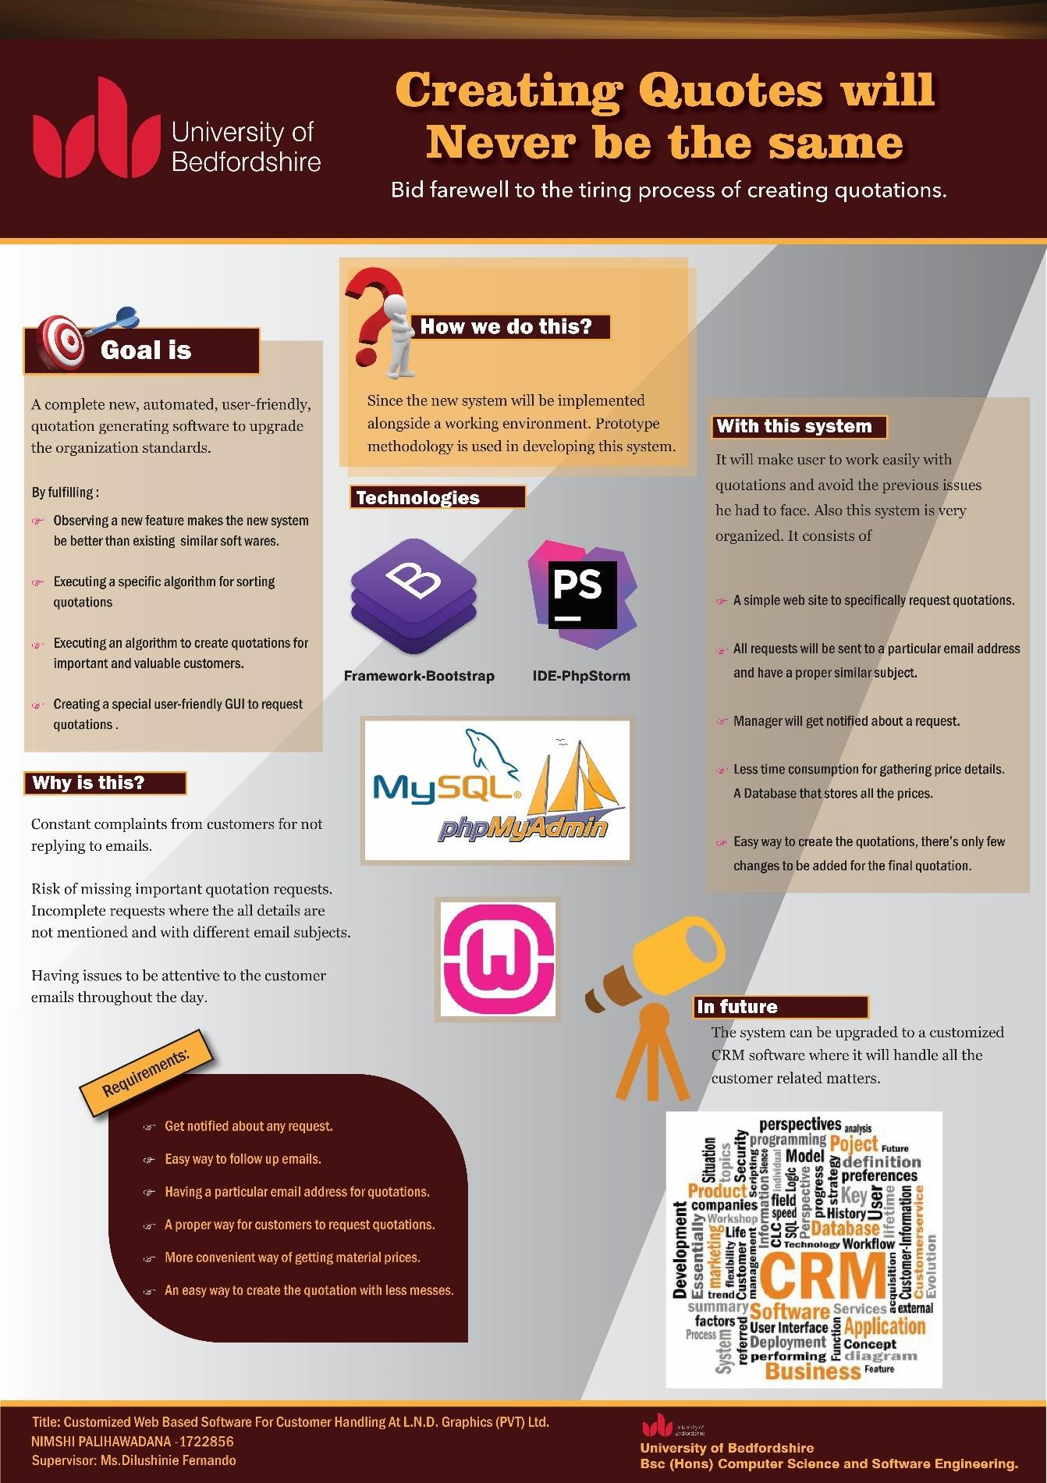

*Figure 34:Poster*

76

77